**EMERGING METHOD FOR EARLY DETECTION OF FOREST FIRE**

Submitted by

**KALAIYARASAN K**

**JOE MATHEW S**

**BALAJI R**

**SRIDHARAN T**

**BACHELOR OF TECHNOLOGY**

**In**

**INFORMATION TECHNOLOGY**

**BANNARI AMMAM INSTITUTE OF TECHNOLOGY**

**SATHYAMANGALAM**

**TEAM ID:** **PNT2022TMID01972**

**TABLE OF CONTENTS**

|  |  |  |
| --- | --- | --- |
| **CHAPTER NO** | **TITLE** | **PAGENO** |
| **1** | **INTRODUCTION**  1.1 Project Overview  1.2 Purpose |  |
| **2** | **LITERATURE SURVEY**  2.2 Existing System  2.2 References  2.3 Problem Statement Definition |  |
| **3** | **IDEATHON & PROPOSED SOLUTION**  3.1 Empathy Map Canvas  3.2 Ideation & Brainstorming  3.3 Proposed Solution  3.4 Problem Solution Fit |  |
| **4** | **REQUIREMENT ANALYSIS**  4.1 Functional Requirement  4.2Non-Functional Requirement |  |
| **5** | **PROJECT DESIGN**  5.1 Data Flow Diagrams  5.1 Solution & Technical Architecture |  |
| **6** | **PROJECT PLANNING & SCHEDULING**  6.1 Sprint Planning, Schedule & Estimation  6.2 Sprint Delivery Schedule  6.3 Reports From JIRA |  |
| **7** | **CODING & SOLUTIONING**  7.1 Feature  7.2 Feature  7.3 Database Schema |  |
| **8** | **TESTING**  8.1 Test cases  8.2 User Acceptance Testing |  |
| **9** | **RESULTS**  9.1 Performance Metrics |  |
| **10** | **ADVANTAGES & DISADVANTAGES** |  |
| **11** | **CONCLUSION** |  |
| **12** | **FUTURE SCOPE** |  |
| **13** | **APPENDIX** |  |

1. **INTRODUCTION**

**1.1 PROJECT OVERVIEW**

From sprawling urbans to dense jungles, fire accidents pose a major threat to the world. These could be prevented by deploying fire detection systems, but the prohibitive cost, false alarms, need for dedicated infrastructure, and the overall lack of robustness of the present hardware and software-based detection systems have served as roadblocks in this direction. In this work, we endeavor to make a stride towards detection of fire in videos using Deep learning. Deep learning is an emerging concept based on artificial neural networks and has achieved exceptional results in various fields including computer vision. We plan to overcome the shortcomings of the present systems and provide an accurate and precise system to detect fires as early as possible and capable of working in various environments thereby saving innumerable lives and resources.

**1.2 PURPOSE**

The proposed framework utilizes the advantages of a convolutional neural network. The CNN receives input, it is preprocessed and pools them using region of proposals. Then the region-based object detection algorithm in CNN classifies those proposals into fire and non-fire in the region of interest (ROI) with the help of convolutional layers.

**2. LITERATURE SURVEY**

**2.1 Existing problem**

The existing system for detecting fire are smoke alarms and heat alarms. The main disadvantage of the smoke sensor alarm and heat sensor alarms are that just one module is not enough to monitor all the potential fire prone places. The only way to prevent a fire is to be cautious al the time. Even if they are installed in every nook and corner, it just is not sufficient for an efficient output consistently. As the number of smoke sensor requirement increase the cost will also increase to its multiple. The proposed system can produce consistent and highly accurate alerts within seconds of accident of the fire. It reduces cost because only one software is enough to power the entire network of surveillance. Research is active on this field by data scientists and machine learning researchers. The real challenge is to minimize the error in detection of fire and sending alerts at the right time.

**2.2 References**

[1]. Janku P., Kominkova Oplatkova Z., Dulik T., Snopek P. and Liba J. 2018. “Fire Detection in Video Stream by Using Simple Artificial Neural”. Network. MENDEL. 24, 2 (Dec. 2018), 55–60.

[2]. Shen, D., Chen, X., Nguyen, M., & Yan, W. Q. (2018). “Flame detection using deep learning”. 2018 4th International Conference on Control, Automation and Robotics (ICCAR).

[3]. Li, C., & Bai, Y. (2018). “Fire Flame Image Detection Based on Transfer Learning”. 2018 5th IEEE International Conference on Cloud Computing and Intelligence Systems (CCIS).

[4]. K. Muhammad, J. Ahmad, I. Mehmood, S. Rho and S. W. Baik, “Convolutional Neural Networks Based Fire Detection in Surveillance Videos," in IEEE Access, vol. 6, pp. 18174-18183, 2018.

[5]. K. Muhammad, J. Ahmad, Z. Lv, P. Bellavista, P. Yang and S. W. Baik, “Efficient Deep CNN-Based Fire Detection and Localization in Video Surveillance Applications,” in IEEE Transactions on Systems,Man, and Cybernetics: Systems, vol. 49, no. 7, pp. 1419-1434, July 2019.

**2.3 Problem Statement Definition**

|  |  |
| --- | --- |
| **QUESTION** | **DESCRIPTION** |
| **What is the problem?** | **loss of biodiversity and**  **extinction of plants and animals.** |
| **what is problem occurs?** | **Nature causes - Many forest fires start from natural causes such as lighting which set trees on fire.** |
| **How to control forest fires?** | **Which can be done by creating firebreaks in the shape of small clearings of ditches in the**  **forests.** |
| **When issue will be identified?** | **Existing detection methods such as satellite and optical systems can cover large areas.** |
| **Why we need to fix problem?** | **For preventing and controlling a forest fires.** |

**3.IDEATION AND PROPOSED SOLUTION**

**3.1 Empathy Map Canvas**

This map is created with view of the project in user's perspective, to find pain & gain points and to summarize it with a list of problem statements.

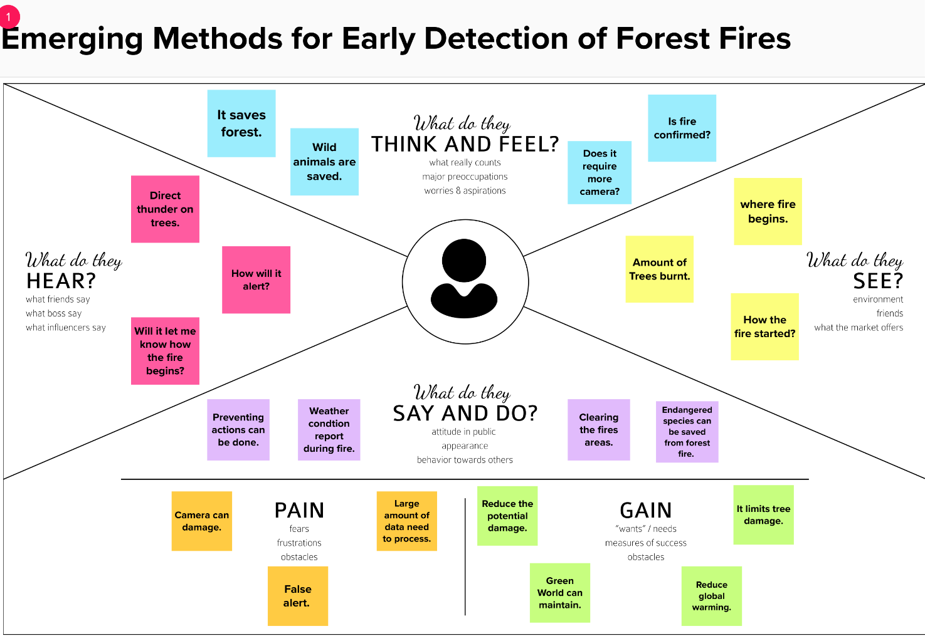

**3.2 IDEATION & BRAINSTORMING**

Brainstorming provides a free and open environment that encourages everyone within a team to participate in the creative thinking process that leads to problem solving. Prioritizing volume over value, out-of-the-box ideas are welcome and built upon, and all participants are encouraged to collaborate, helping each other develop a rich amount of creative solutions. Use this template in your own brainstorming sessions so your team can unleash their imagination and start shaping concepts even if you're not sitting in the same room.

**Step-1: Brainstorm,Idea,Listing and Grouping**

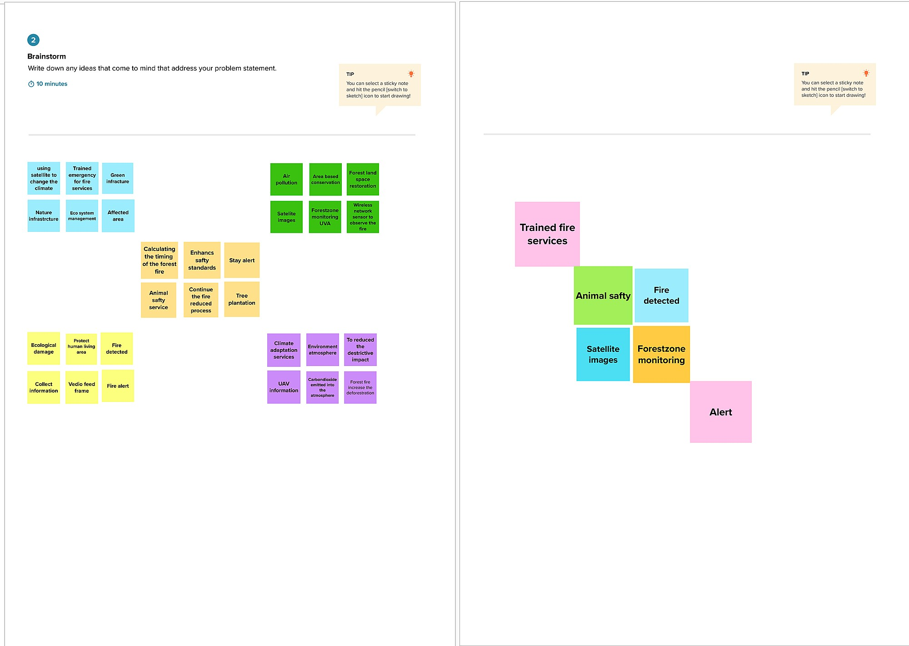

# Step-2: Idea Prioritization

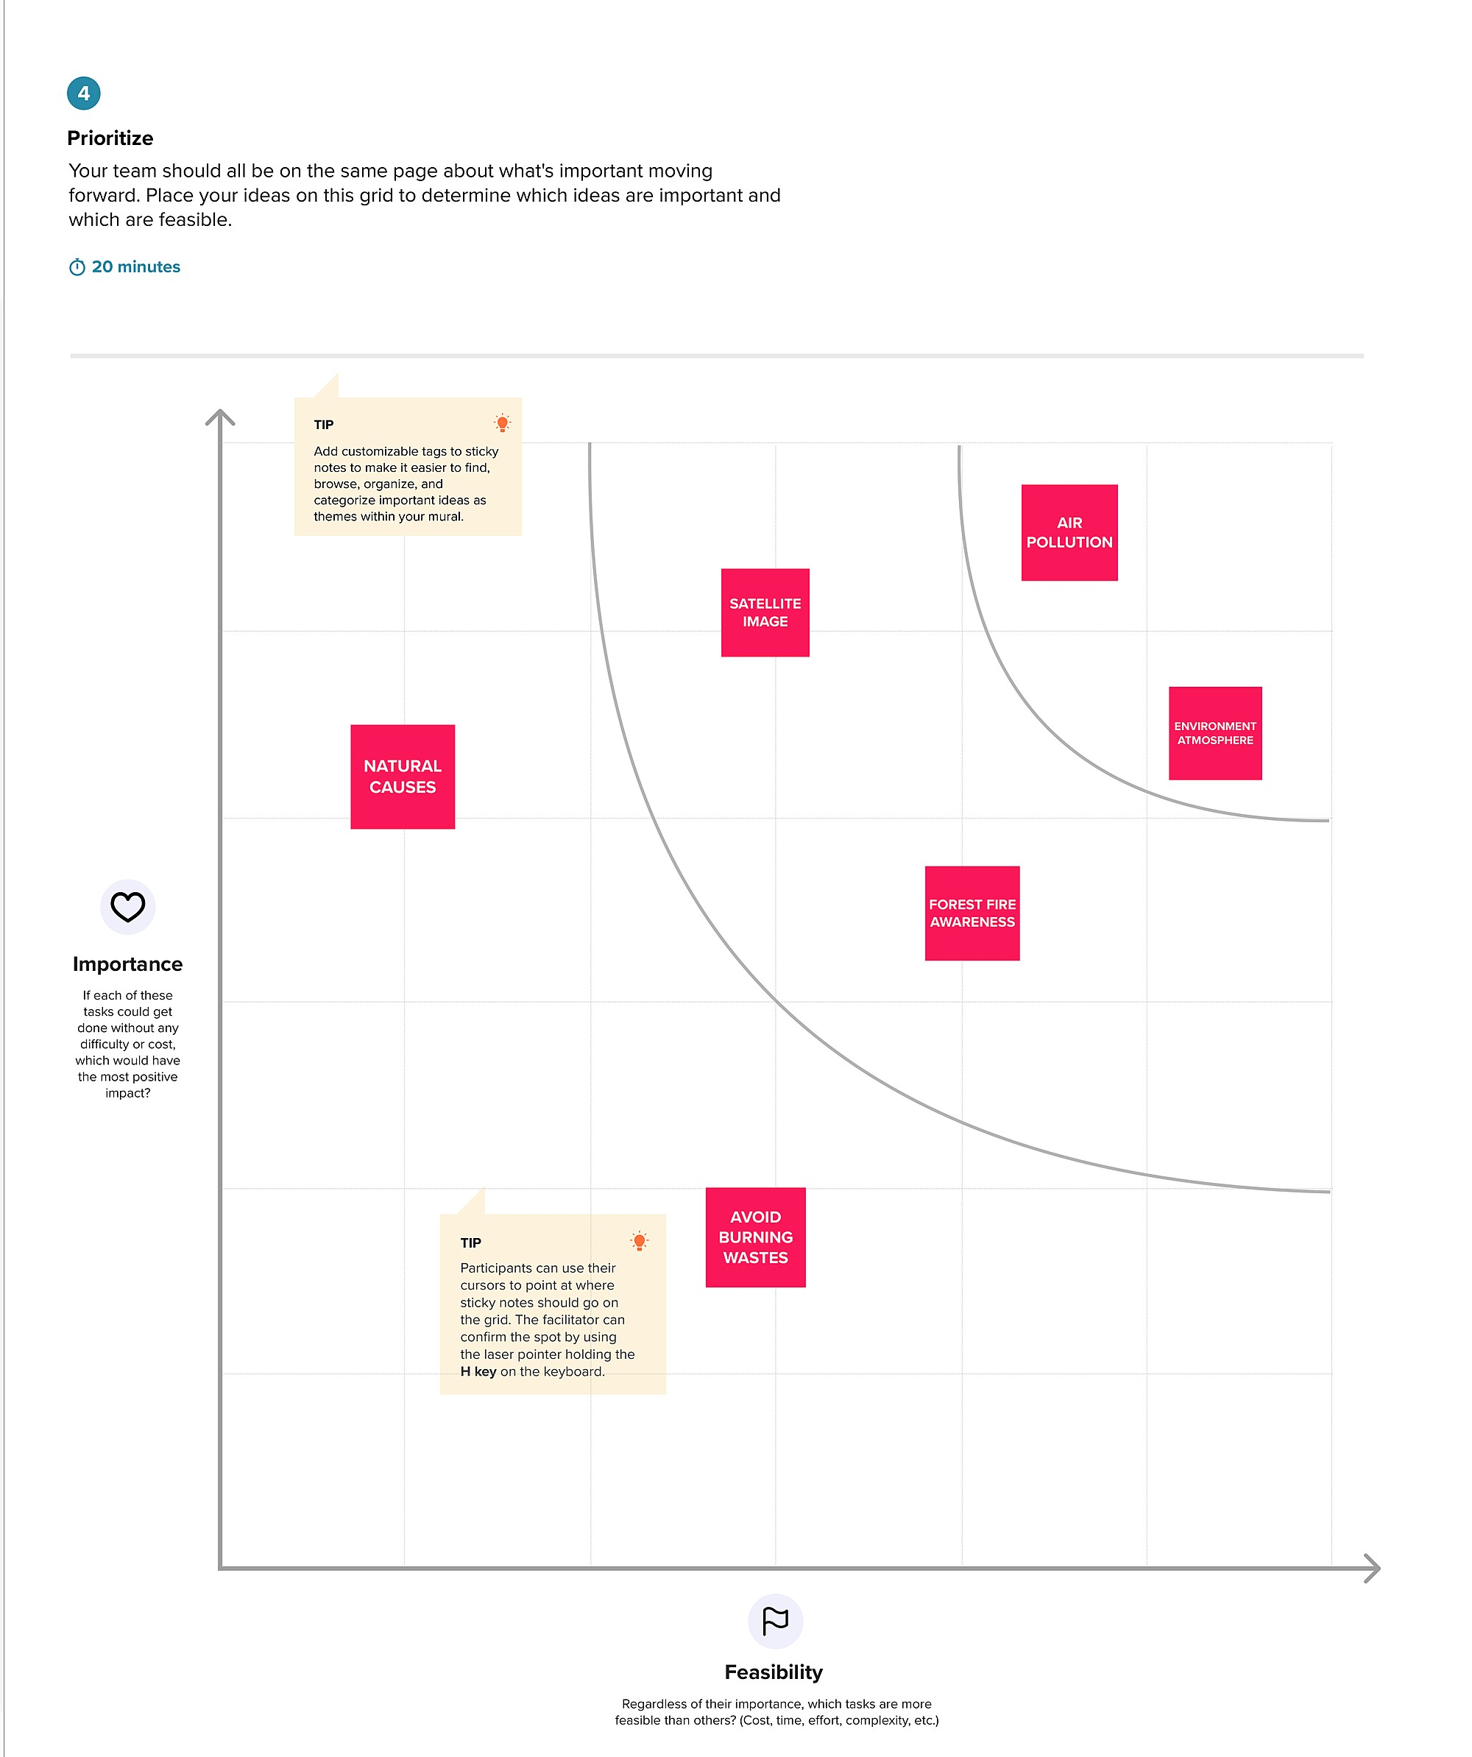

**3.3 PROPOSED SOLUTION**

|  |  |  |
| --- | --- | --- |
| **S.NO** | **Parameter** | **Description** |
| 1. | Problem Statement(Problem to be solved ) | Loss of biodiversity and extinction of plants and animals. Loss of wild life habitat. Loss of natural regeneration and reduction in forest cover,global warming. |
| 2. | Idea /Solution description | Use fire pits in territories protected by the department of natural resources. prepare a bucket of water and a shovle to extinguish the bonfire. |
| 3. | Novelty /Uniqueness | Fire detection systems increase response times, as they are able to alert the correct people in order to extinguish the fire. |
| 4. | Social impact / Customer  Satisfaction | Monitoring of the potential risk areas and an early detection of forest fires can significantly shorten the reaction time. |
| 5. | Business Model(Revenue  Model) | Due to various shapes,textures and colors of fires,forest fire detection is challenging task. |
| 6. | Scalability of the Solution | Using a coupled multi-physics system to predict the evolution of a forest fires is the ability of capturing the effect of meteorological events . |

**3.4 PROBLEM SOLUTION FIT**

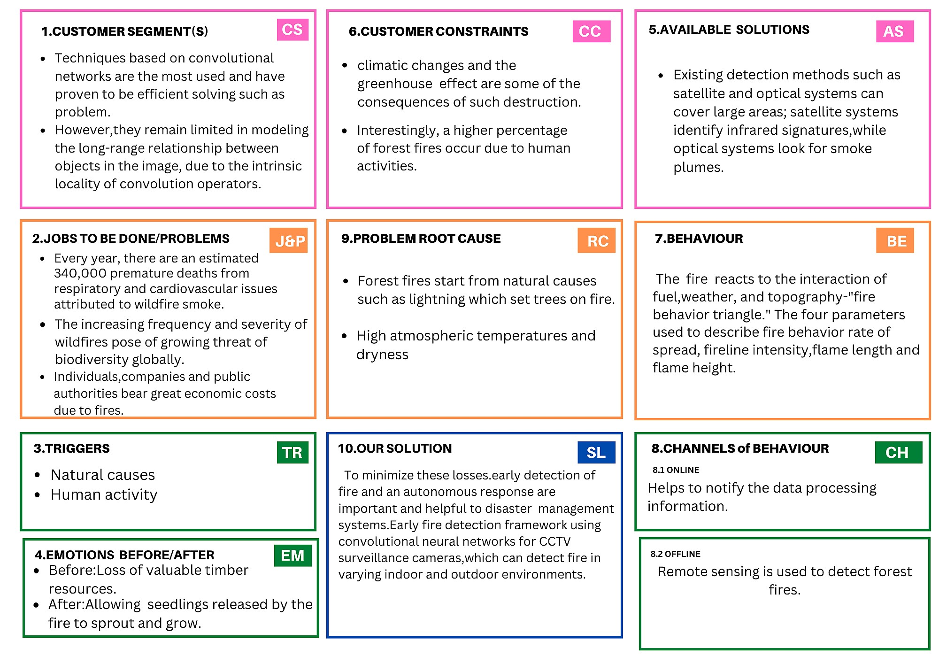

**4.REQUIREMENT ANALYSIS**

**4.1 FUNCTIONAL REQUIREMENTS**

|  |  |  |
| --- | --- | --- |
| **FR No** | **Functional Requirement (Epic)** | **Sub Requirement (Story / Sub-Task)** |
| FR No-1 | Video surveillance start | Start surveillance through remote control |
| FR No-2 | Forest monitoring | Continuous monitoring through camera |
| FR No-3 | Detect fire | Fire is detected through CNN model |
| FR No-4 | Alert | Alert the forest officials through  message |

**4.2 NON-FUNCTIONAL REQUIREMENTS**

|  |  |  |
| --- | --- | --- |
| **NFR No.** | **Non-Functional Requirement** | **Description** |
| NFR No-1 | Usability | Monitoring of the potential risk areas and an early detection of fire can significantly shorten the reaction time and also reduce the potential damage as well as the cost of fire fighting. |
| NFR No-2 | Security | More secure environment. |
| NFR No-3 | Reliability | Model is safe to install. |
| NFR No-4 | Performance | Model will achieve high accuracy. |
| NFR No-5 | Availability | Build model is available all the time. |
| NFR No-6 | Scalability | The current requirement for a cargo compartment detection system is that a fire has to be detected in 1 minute, and in that time be so small that the fire is not a significant hazard to the airplane. Nuisance alarms also plague the industry, with upwards of  90% of fire alarms being false warnings. |

**5.PROJECT DESIGN**

**5.1 DATA FLOW DIAGRAMS**

A Data Flow Diagram (DFD) is a traditional visual representation of the information flows within a system. A neat and clear DFD can depict the right amount of the system requirement graphically. It shows how data enters and leaves the system, what changes the information, and where data is stored.

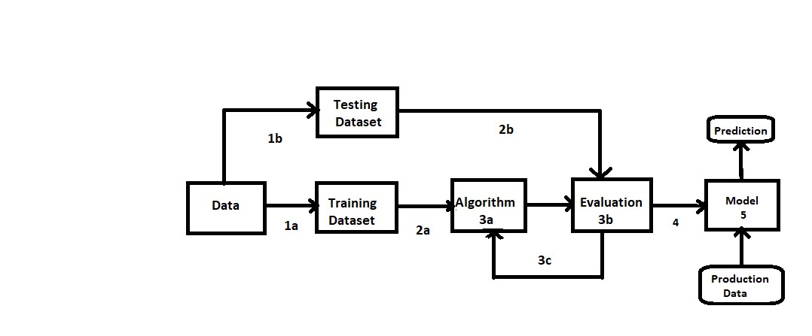

**1.Data set**

**2.Evaluate Dataset**

**3.Implement Algorithm**

**4.Evaluate accuracy of algorithms**

**5. Display Results**

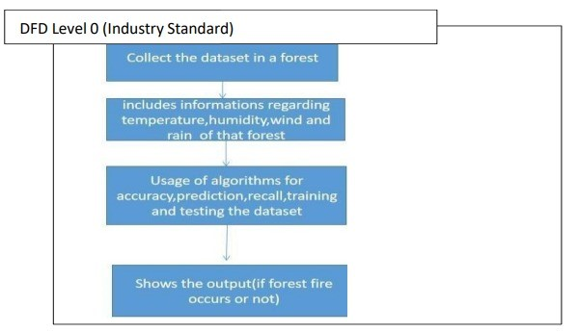

**5.2 SOLUTION & TECHNICAL ARCHITECTURE**

Solution Architecture is a complex process-with many sub-process-that bridges the gap between business problem and technologies solutions; It goals are to.

* Find the best tech solutions to solve existing business problems.
* Describe the structure, characteristics, behavior and the aspects of the software to project stakeholders.
* Define the features, development phases and solution requirements.
* Provide specifications according to which the solution is defined, managed and delivered.

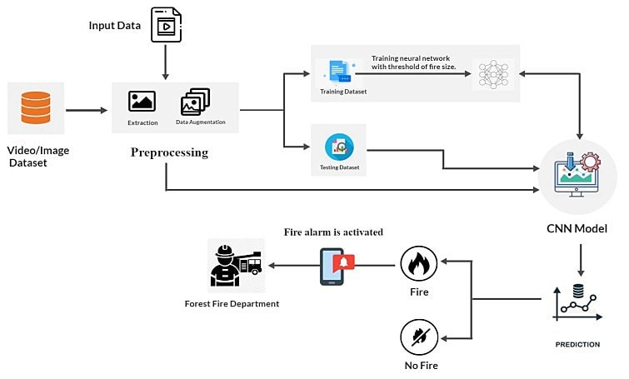

**5.3 User Stories**

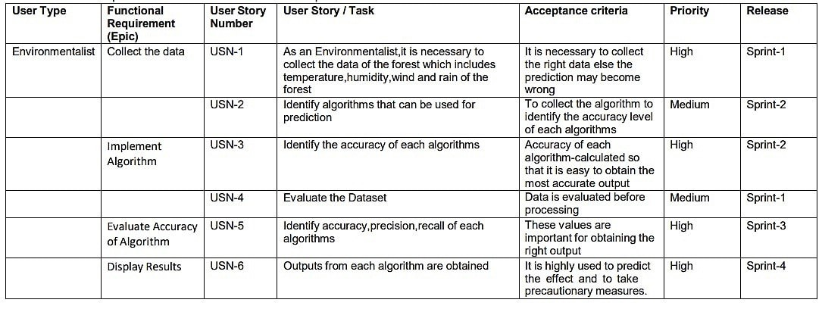

**6. PROJECT PLANNING & SCHEDULING**

**6.1 SPRINT PLANNING & ESTIMATION**

|  |  |  |  |  |  |  |
| --- | --- | --- | --- | --- | --- | --- |
| **Sprint** | **Functional**  **Requirement (Epic)** | **User Story**  **Number** | **User Story / Task** | **Story Points** | **Priority** | **Team Members** |
| Sprint-2 | Registration | USN-1 | As a user, I can register for the application by entering my email, password, and confirming my password. | 3 | Medium | Preethi R, Kavitha M  Priya M, Srimathi G |
| Sprint-2 |  | USN-2 | As a user, I will receive confirmation email once I have registered for the application | 2 | Low | Preethi R, Kavitha M  Anushti K, Srimathi G |
| Sprint-3 |  | USN-3 | As a user, I can register for the application through Facebook | 2 | Low | Preethi R, Kavitha M |
| Sprint-3 |  | USN-4 | As a user, I can register for the application through Gmail | 3 | Medium | Preethi R, Kavitha M  Priya M |
| Sprint-2 | Login | USN-5 | As a user, I can log into the application by entering email & password | 3 | Medium | Anushti K, Srimathi G,Preethi R |
| Sprint -1 | Dataset | USN-6 | The dataset is collected and pre-processed and split for training and testing. | 5 | High | Preethi R, Kavitha M  Anushti K, Srimathi G  Priya M |
| Sprint -1 |  | USN-7 | The model is created and trained using test and train dataset. | 5 | High | Preethi R, Kavitha M |

**6.2 Sprint Delivery Schedule**

|  |  |  |  |  |  |  |
| --- | --- | --- | --- | --- | --- | --- |
| **Sprint** | **Total Story Points** | **Duration** | **Sprint Start Date** | **Sprint End Date**  **(Planned)** | **Story Points**  **Completed (as on**  **Planned End Date)** | **Sprint Release Date**  **(Actual)** |
| Sprint-1 | 20 | 6 Days | 24 Oct 2022 | 29 Oct 2022 | 20 | 29 Oct 2022 |
| Sprint-2 | 20 | 6 Days | 31 Oct 2022 | 05 Nov 2022 | 20 | 05 Nov 2022 |
| Sprint-3 | 20 | 6 Days | 07 Nov 2022 | 12 Nov 2022 | 20 | 12 Nov 2022 |
| Sprint-4 | 20 | 6 Days | 14 Nov 2022 | 19 Nov 2022 | 20 | 19 Nov 2022 |

**6.3 Reports From JIRA**

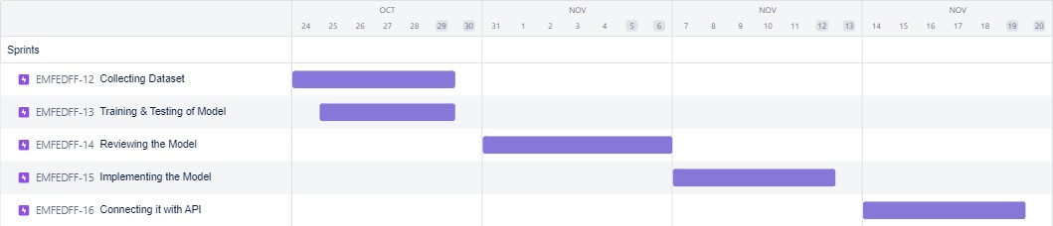

**7.CODING & SOLUTIONING**

**7.1 Feature**

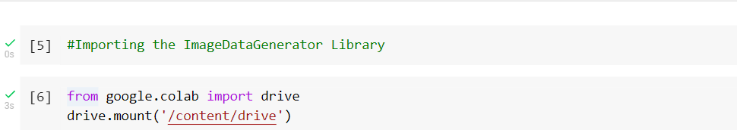



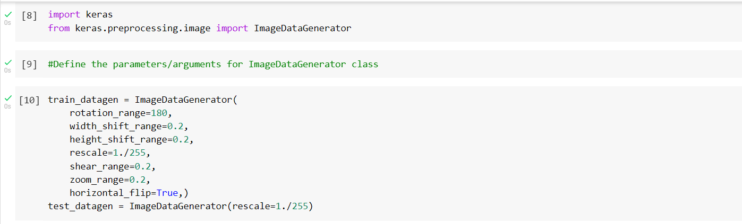

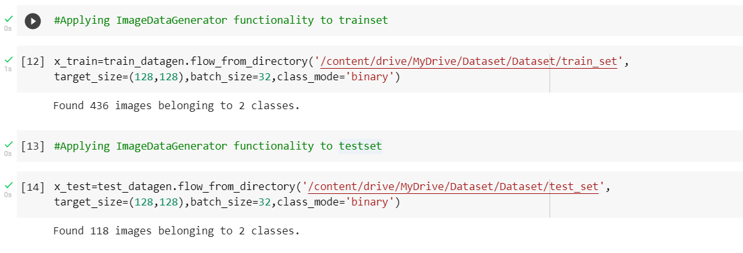

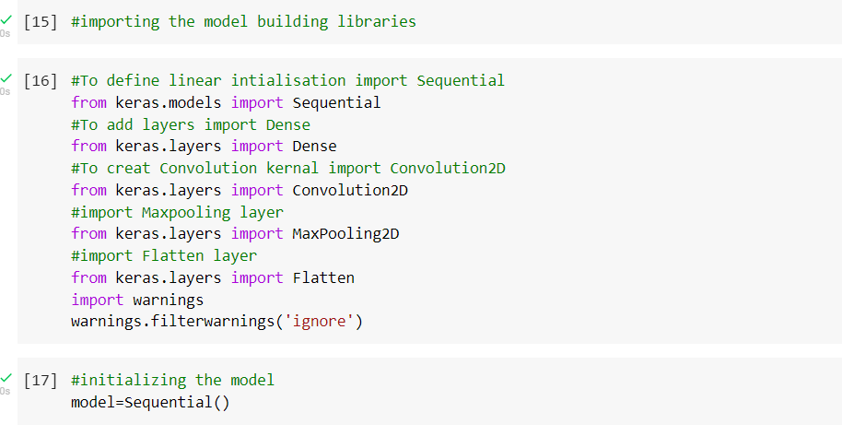

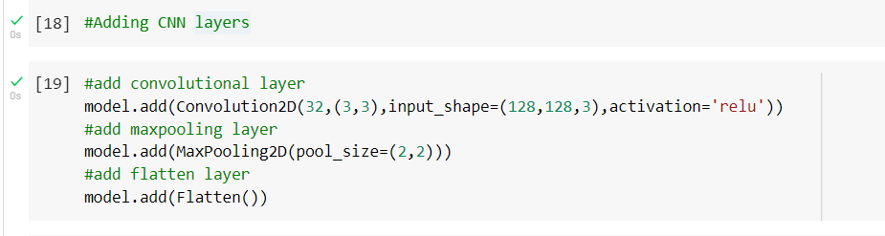

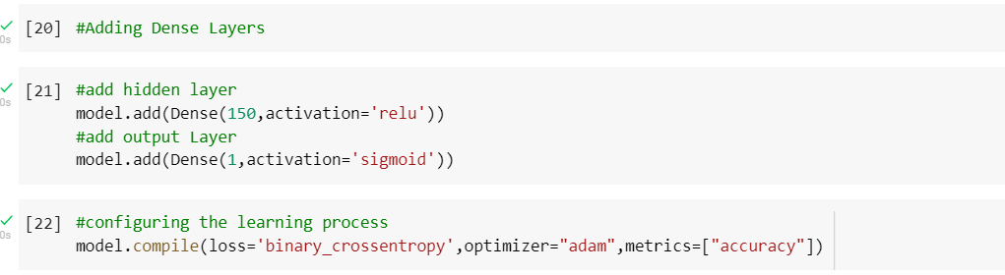

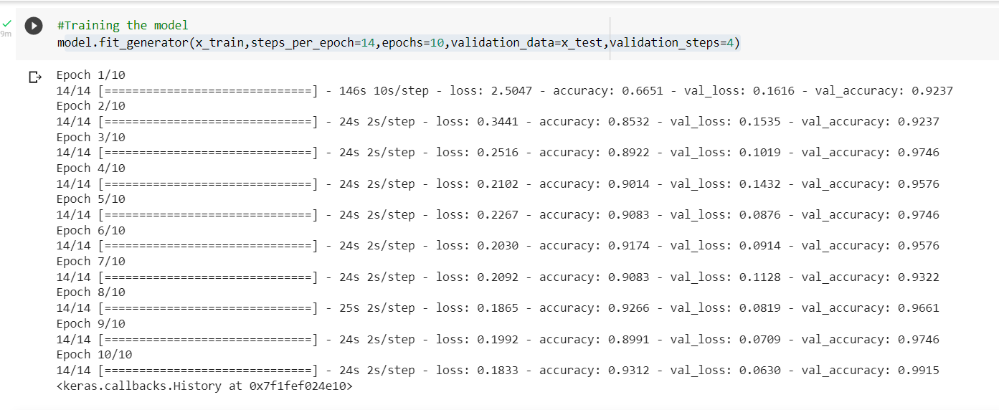

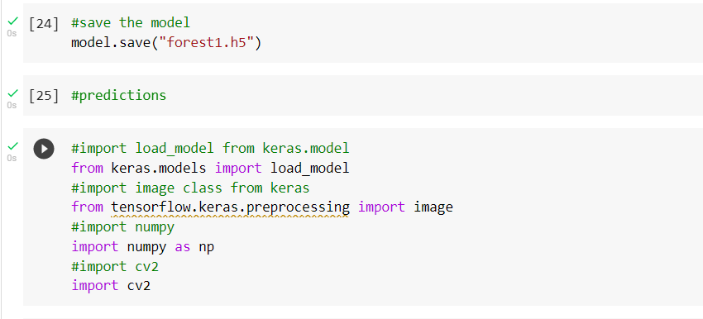

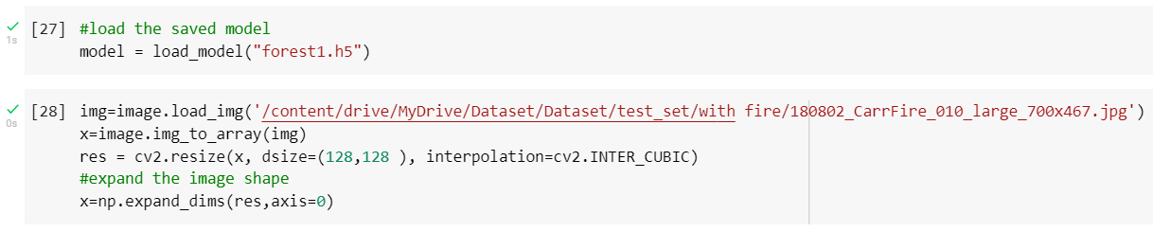

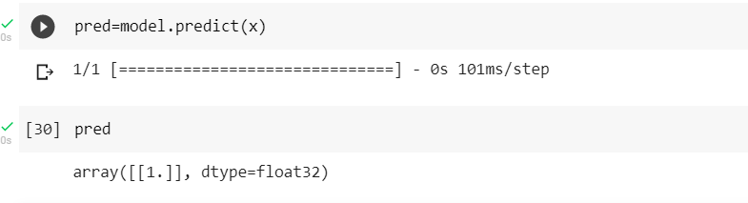

**7.2 Feature**

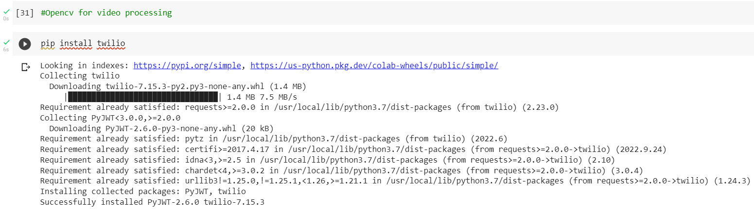

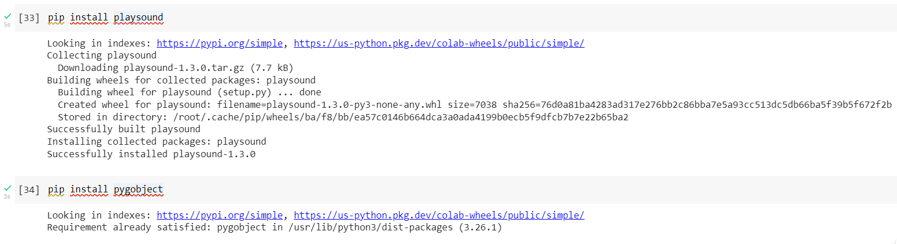

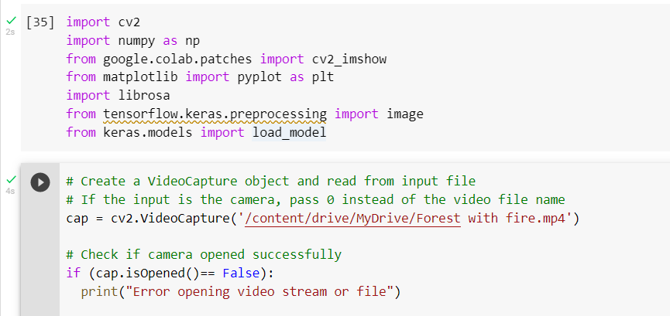

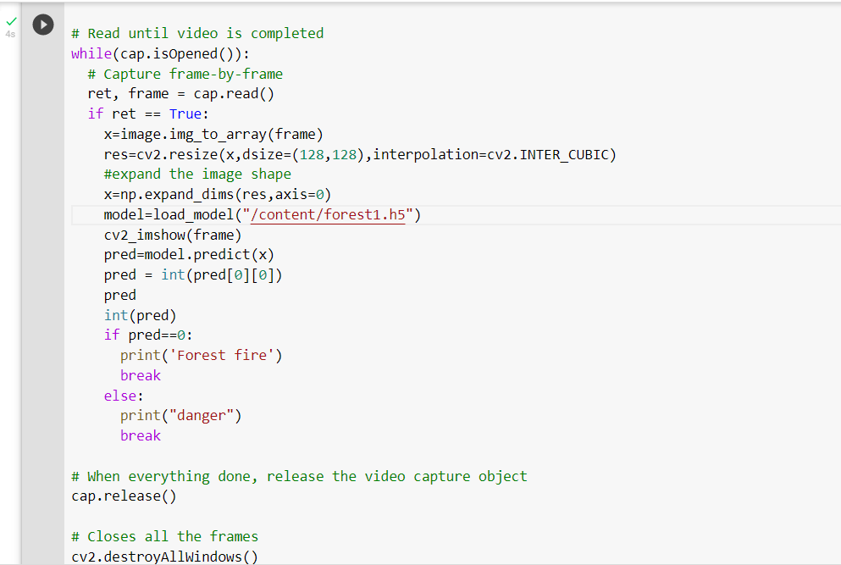



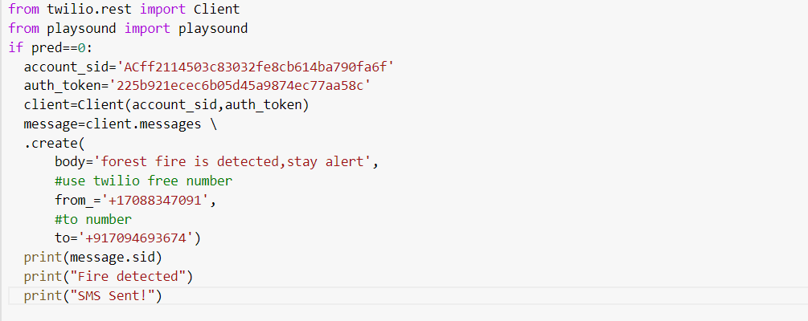

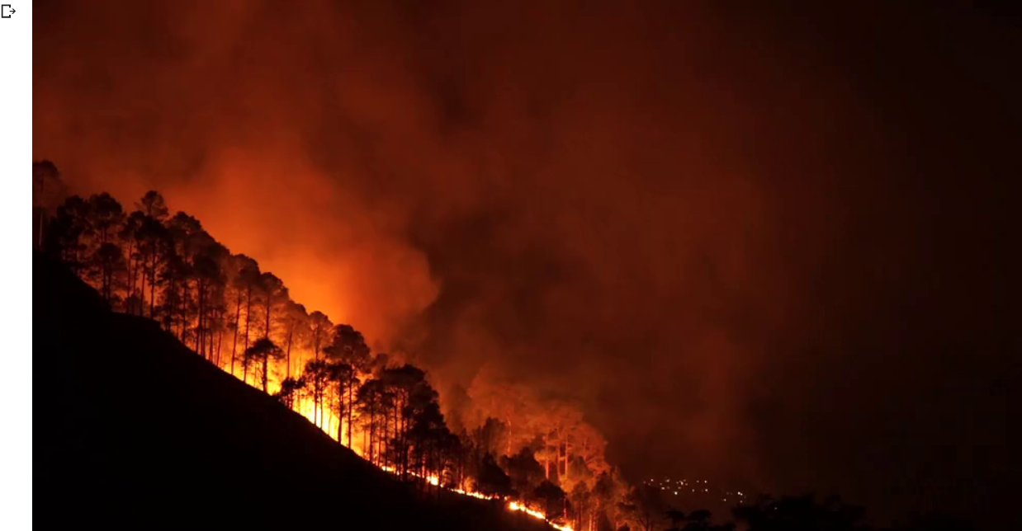

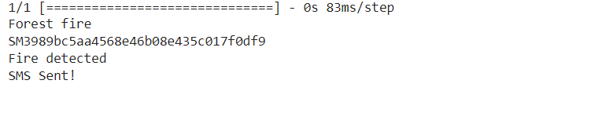

**Message output**

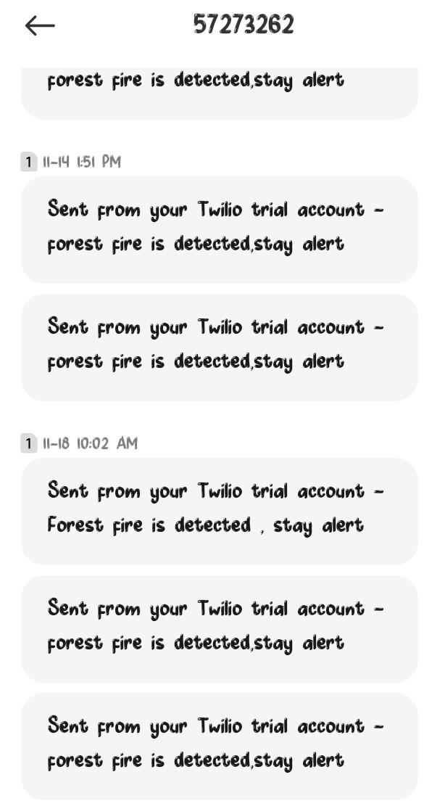

**8.TESTING**

**8.1 Test cases**

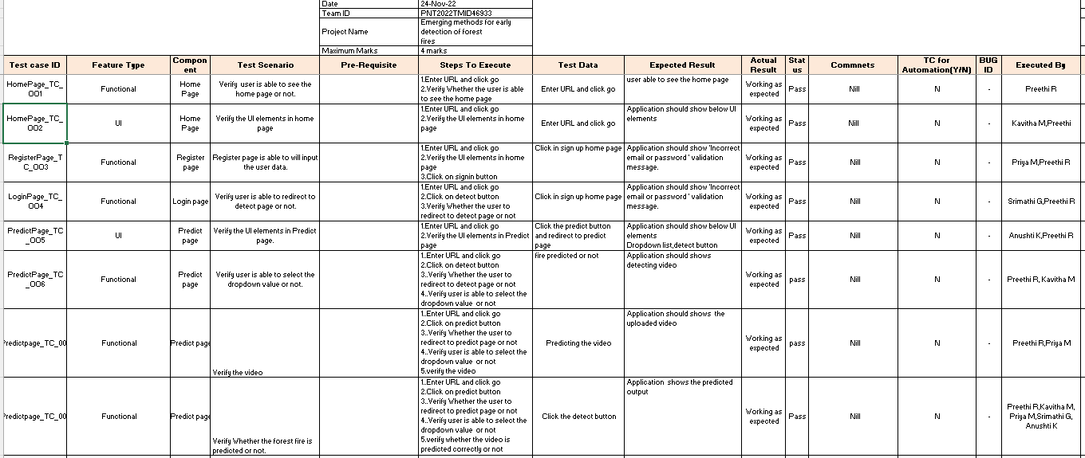

**8.2 User Acceptance Testing**

# 1.Purpose of Document

The purpose of this document is to briefly explain the test coverage and open issues of the [ProductName] project at the time of the release to User Acceptance Testing (UAT).

# 2.Defect Analysis

This report shows the number of resolved or closed bugs at each severity level, and how they were resolved

|  |  |  |  |  |  |
| --- | --- | --- | --- | --- | --- |
| **Resolution** | **Severity 1** | **Severity 2** | **Severity 3** | **Severity 4** | **Subtotal** |
| By Design | 1 | 0 | 0 | 0 | 1 |
| Duplicate | 0 | 0 | 0 | 0 | 0 |
| External | 0 | 0 | 0 | 0 | 0 |
| Fixed | 0 | 0 | 0 | 0 | 0 |
| Not Reproduced | 0 | 2 | 0 | 0 | 2 |
| Skipped | 0 | 0 | 0 | 0 | 0 |
| Won't Fix | 0 | 0 | 0 | 0 | 0 |
| Totals | 1 | 2 | 0 | 0 | 3 |

**3.Test Case Analysis**

This report shows the number of test cases that have passed, failed, and untested

|  |  |  |  |  |
| --- | --- | --- | --- | --- |
| **Section** | **Total Cases** | **Not Tested** | **Fail** | **Pass** |
| Performance | 5 | 0 | 0 | 5 |
| UI | 1 | 0 | 0 | 1 |
| Security | 3 | 0 | 0 | 3 |

**9.Results**

**9.1 Performance Metrics**

**Model Performance Testing:**

Project team shall fill the following information in model performance testing template.

|  |  |  |  |
| --- | --- | --- | --- |
| **S.No.** | **Parameter** | **Values** | **Screenshot** |
| 1. | Model  Summary | Total params: 19,052,397  Trainable params: 19,052,397  Non-Trainable params: 0 |  |
| 2. | Accuracy | Training Accuracy – 12.68    Validation Accuracy -13.07 |  |

# Model Summary

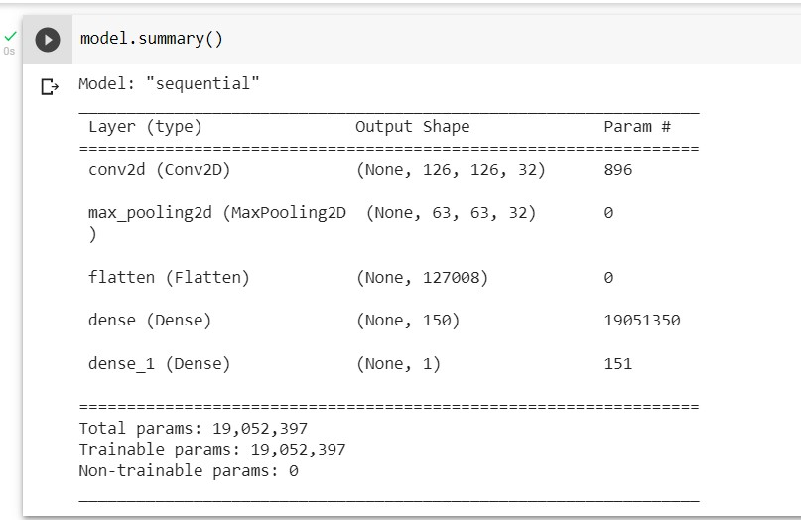

**Accuracy**

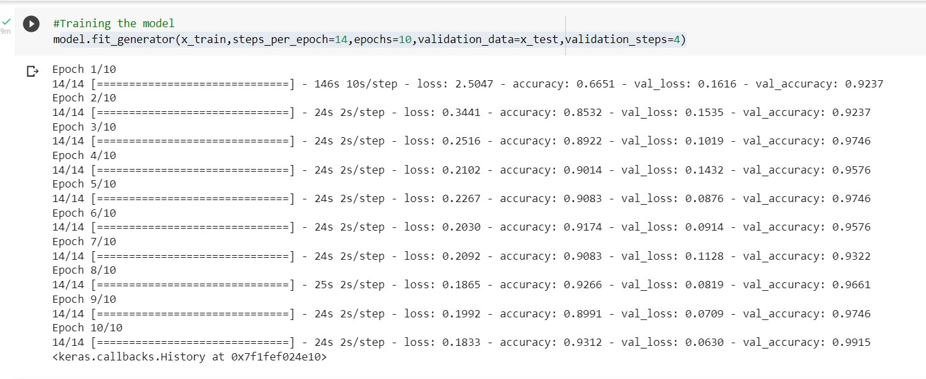

**10.ADVANTAGES & DISADVANTAGES**

**ADVANTAGES**

* Fire removes low-growing underbrush, cleans the forest floor of debris, opens it up to sunlight, and nourishes the soil.
* Reducing this competition for nutrients allows established trees to grow stronger and healthier.
* History teaches us that hundreds of years ago forests had fewer, yet larger, healthier trees.
* Fire kills diseases and insects that prey on trees and provides valuable nutrients that enrich the soil.

**DISADVANTAGES**

* + Forest fires can create health problems for people.
  + Forest fires can trigger mudslides, landslides, and other forms of erosion.
  + Forest fires under control can still burn other structures .
  + The cutting down of forests leads to a loss in biodiversity.

**11. CONCLUSION**

A Deep Learning based Convolutional Neural Network (CNN) model is presented to detect a forest fire. The following techniques such as Image Collection, Preprocessing, Image Classification, Model building and video streaming and alerting is done. Initially, the images in the dataset are pre-processed, and fed into the CNN for feature extraction and detection.

**12.FUTURE SCOPE**

* The scope of using video frames in the detection of fire using CNN is challenging as well as innovative. If this system with less error rate can be implemented at a large scale like in big factories, houses, forests, it is possible to prevent damage and loss due to random fire accidents by making use of the Surveillance systems.
* The proposed system can be developed to more advanced system by integrating wireless sensors for added protection and precision. The algorithm shows great promise in adapting to various environment.
* Future studies may focus on deploying the model into Database and cloud storage and using necessary support packages to detect the real time fire by making challenging and specific scene understanding datasets for fire detection methods and detailed experiments with Large datasets and training models.

**13.APPENTEX**

**GitHub**

[**https://github.com/IBM-EPBL/IBM-Project-8259-1658913326**](https://github.com/IBM-EPBL/IBM-Project-8259-1658913326)